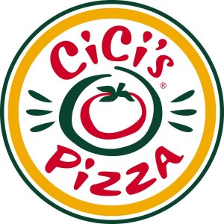 Already enjoy pizza, pasta, and breadsticks?
CiCi’s Pizza Spirit Night
Great!

Join us Wednesday, December 14, 2011
at

CiCi’s Pizza
4360 S. Laburnum Avenue
Richmond, VA 23231
(804) 726-9464
5:00pm – 8:00pm

to enjoy great food for a GREAT cause:

George W. Carver PTA!

Just remember to put your receipt in the fundraising bucket when you pay at the counter.

LIKE us on Facebook at www.facebook.com/gwcarverpta
to stay informed of our upcoming events!!

