**John B. Cary Food Drive benefiting**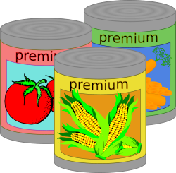

***H.H.O.P.E* Food Pantry**

The week of **October 12-16th** JBC PTA will be having a food drive to benefit ***H.H.O.P.E* Food Bank. *H.H.O.P.E Food Bank*** serves the Richmond and Henrico Communities.

***H.H.O.P.E*** is in need of all canned/packaged food: canned fruit/vegetables, packaged spaghetti and can/jar spaghetti sauce, cereal/oatmeal, jelly

***H.H.O.P.E*** is also in need of non-food items: dishwashing detergent, deodorant, toothpaste, soap, shampoo and diapers (especially size 5 & 6)

***\*By contributing to the JBC/PTA food drive you are helping serve students, along with residents who are deaf and blind who live in the Richmond metro area and families served by Lutheran Family services to meet emergency-needs of guests referred by Central Virginia Food Bank\****

We thank you in advance for donating to such a great cause! Food Items can be dropped off in the collection boxes located in the main hallway.

Join us on Facebook “John B. Cary Elementary PTA” email:jbcpta@gmail.com