“Connecting Home, School and the Community to Achieve Success”

**J.E.B. Stuart Elementary School**

**C:\Documents and Settings\Guest\Local Settings\Temporary Internet Files\Content.IE5\6R7TB5JF\MC900434461[1].wmf3rd Annual “Extravaganza”**

C:\Users\toney\AppData\Local\Microsoft\Windows\Temporary Internet Files\Content.IE5\2FN8BEGF\MC900001760[1].wmfWhen: Saturday, October 17, 2015

**Food!**

**Vendors!**

**Yard Sales!**

**FUN!**

**Music!**

**GAMES!**

**RAFFLES**

Where: J.E.B. Stuart Elementary School

3101 Fendall Avenue

Time: 10AM-2PM

C:\Users\toney\AppData\Local\Microsoft\Windows\Temporary Internet Files\Content.IE5\DDFGNKWH\MC900297517[1].wmfC:\Users\toney\AppData\Local\Microsoft\Windows\Temporary Internet Files\Content.IE5\DDFGNKWH\MC900338454[1].wmf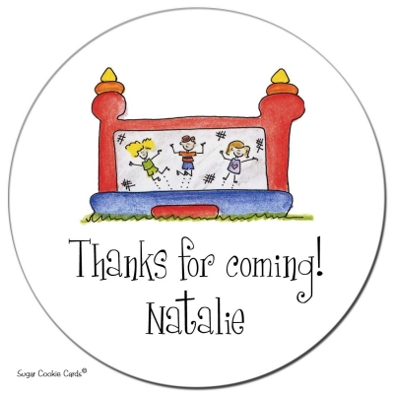

Join the P.T.A.

Receive a Raffle Ticket for Great Prizes

Contact us at 780-4879 or Visit us on Facebook at [www.facebook.com/JEBStuartFallExtravaganza](http://www.facebook.com/JEBStuartFallExtravaganza)



**J.E.B. Stuart Elementary School**

“Connecting Home, School and the Community to Achieve Success”

C:\Documents and Settings\Guest\Local Settings\Temporary Internet Files\Content.IE5\6R7TB5JF\MC900434461[1].wmf3rd Annual “Extravaganza”

Vendor Application

**Due by: October 2, 2015**

Name _____________________________________________________________________

Address____________________________________________________________________

Name of Business _______________________________ Vender ID# __________________

Items Sold (food, jewelry, yard sale, etc.)

___________________________________________________________________________

Average costs________________________________________________________________

Parent of J.E.B. Stuart Student ____Y ____N

Child’s Name ______________________________________ Grade ____________________

The following items will be sold by the school. Please do not sell these items.

*Popcorn *Hot Dogs *Fried Fish

*Cold Drink *Cotton Candy * Hamburgers

Booth Prices: $25(Stuart Parents); $50 (Outside Vendors)

**………………………………………………………………………………………………….**

*\*\*\*Official Use Only\*\*\**

Approved _______________ Denied _______________ Notified _______________

Payment Received _____________ Cash Money Order

Received by ______________________________________ Date ________________________